Setting up environment for AI

Training environment
Steps to install TensorFlow in anaconda prompt to run the training in GPU.
- Install anaconda from - https://www.anaconda.com/products/distribution Anaconda Link
- Select installation directory as D:\Anaconda3
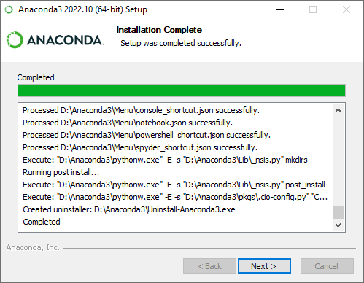
- From start menu open anaconda navigator after the installation.
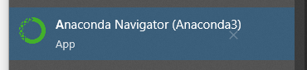
- In anaconda go to Environments in sidebar.
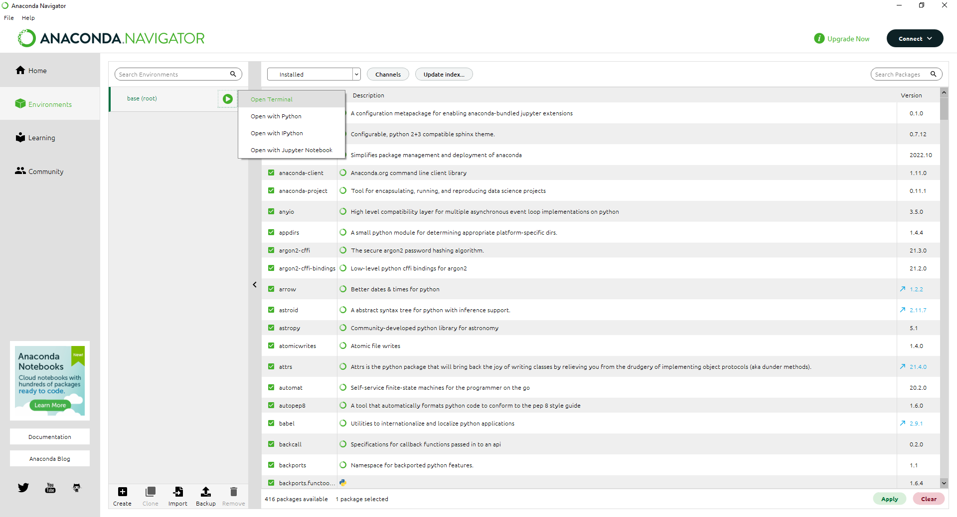
- From base root, click and open terminal as shown in above screenshot.
- Once command prompt opens up, run the below command, for more information visit https://www.tensorflow.org/install/pip#windows-native
conda install -c conda-forge cudatoolkit=11.2 cudnn=8.1.0
- Enter y, when cmd prompts
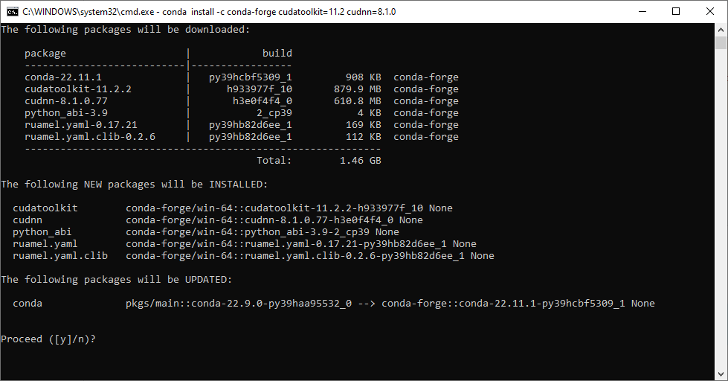
- Install tensorflow using pip3 in same prompt
pip3 install "tensorflow<2.11"
- To test whether tensorflow detected GPU. Run this command.
python -c "import tensorflow as tf; print(tf.config.list_physical_devices('GPU'))"

Labelling and data preparation environment
This section describes the procedure to setup labelling tool.
- Open anaconda prompt as mentioned in previous section. Run below command to install labeling tool.
pip3 install django-labeller
for more information visit GitHub - Britefury/django-labeller: An image labelling tool for creating segmentation data sets, for Django and Flask.
- To run the web-based labeling tool. Use command
python -m image_labelling_tool.flask_labeller --images_dir=<images_directory

Example:
python -m image_labelling_tool.flask_labeller --images_dir=D:/data/region_of_interest

After running the command, verify flask app is runnin. Visit http://localhost:5000/
You should also see Loaded ‘N’ images in command prompt.
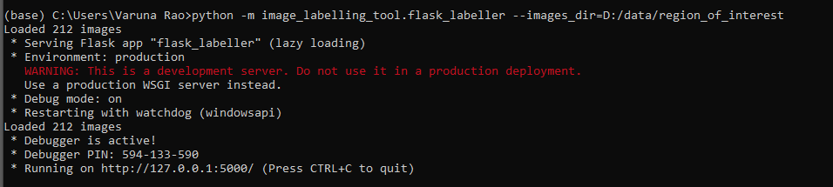

Web app would appear as shown below.
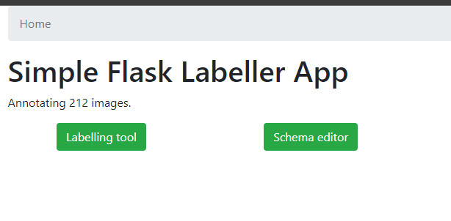
Go to schema editor and add some classes that you want to segment. This is used for generating the ground truth data.

One pressing labelling tool button, you would see 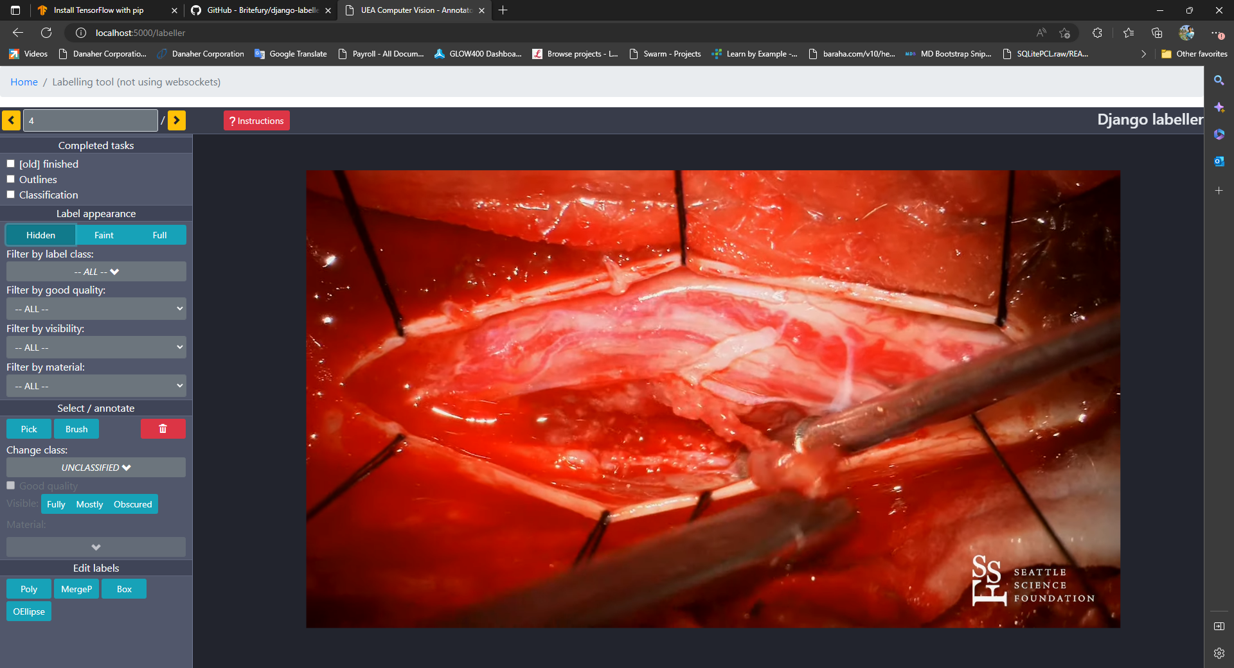

After annotation this is how annotated data would look like.
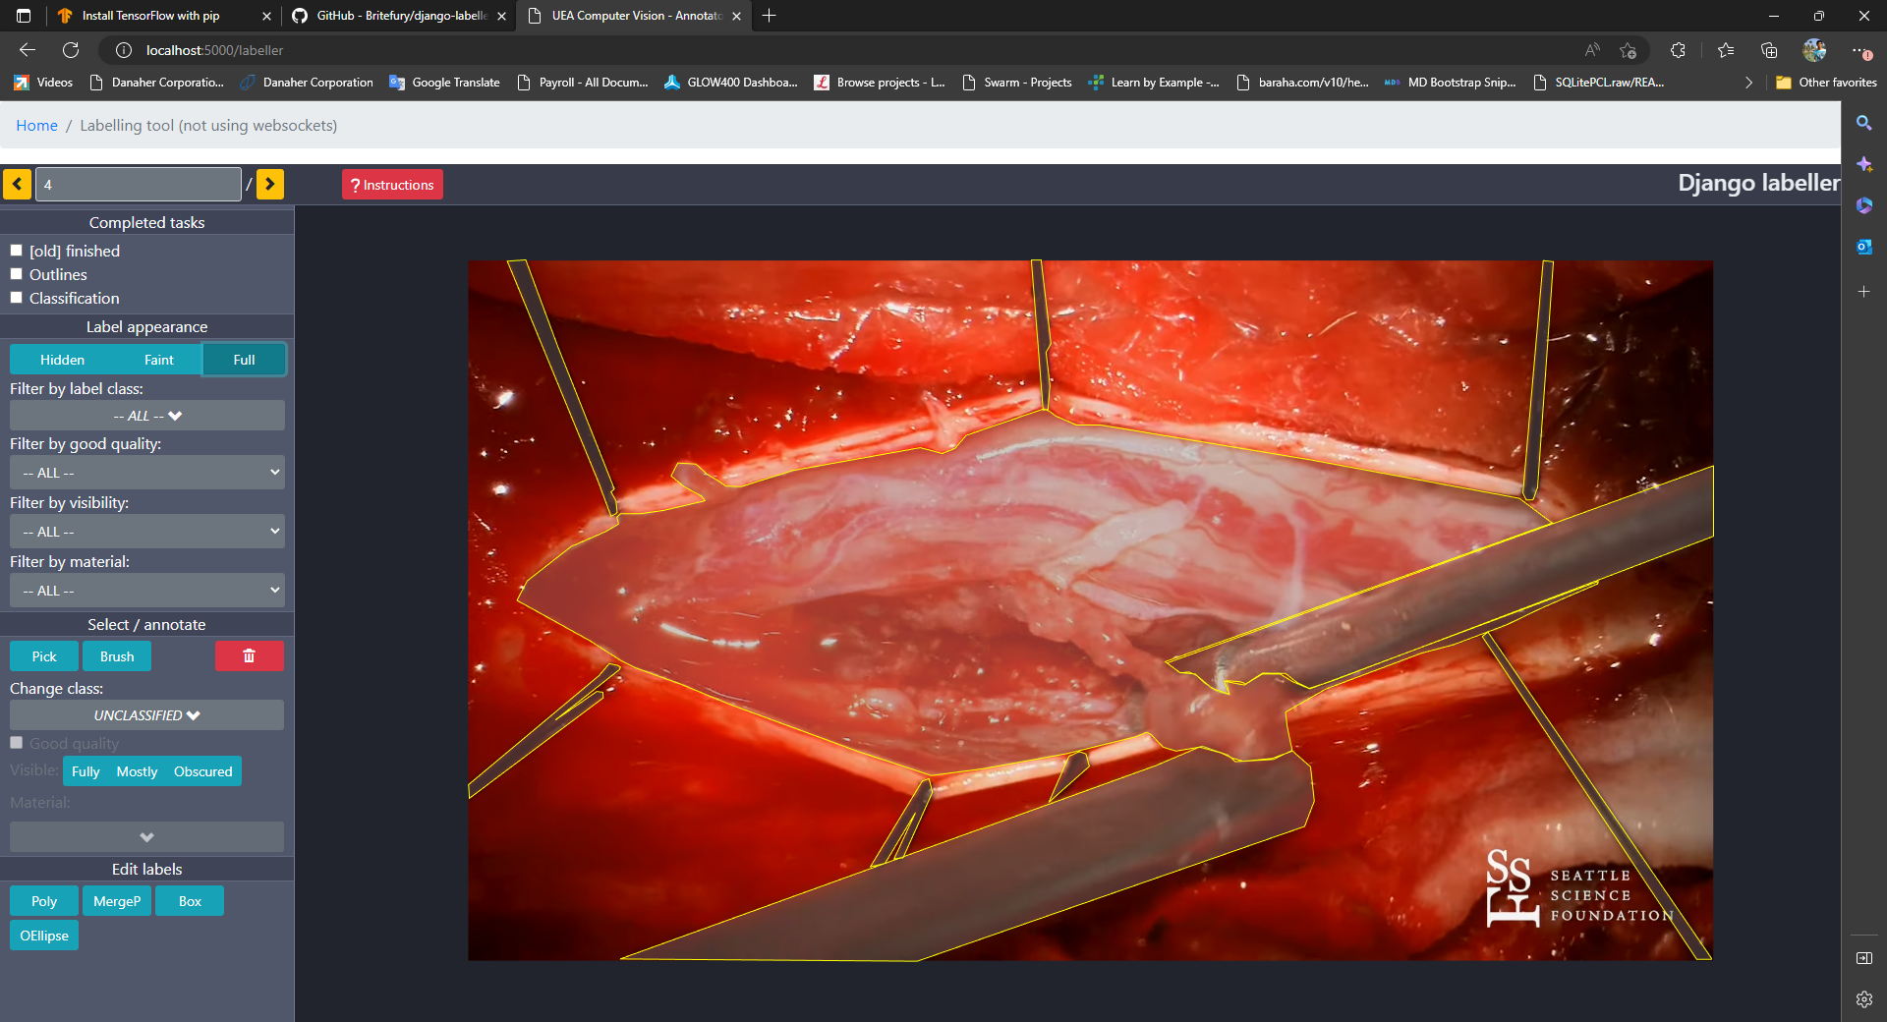

Annotate the ground truth using polygon. You would see json files being created in the same folder as the image directory path you have set as a parameter to labeling tool.

Install additional utilities
- Opencv, image augmenttion for image manipulation
pip3 install opencv-python
pip3 install imgaug
- Jupyterlab set working directory
Run command
jupyter notebook --generate-config
edit jupyter_notebook_config.py after running the command, this command returns the location of the file. Uncomment below line & change the directory of your wish.
# c.NotebookApp.notebook_dir = ''
